**Western Australian Certificate of Education**

**Semester One Examination, 2020**

**Question/Answer Booklet**

**MATHEMATICS**

____

98

**METHODS**

**UNIT 1&2**

**Section Two:**

**Calculator- assumed Score for this booklet**

**Student’s Name**: **_______________________________________**

**As shown on your exam timetable.**

**Student’s Teacher Mr Bellis Mrs Dalby**

(**Circle your teacher’s name**.)

**Mr Hughes Mrs Potier**

**Time allowed for this section**

Reading time before commencing work: ten minutes

Working time for this section: one hundred minutes

**Materials required/recommended for this section**

***To be provided by the supervisor***

This Question /Answer Booklet

Formula Sheet (retained from Section One)

***To be provided by the candidate***

Standard Items: pens (blue/black preferred), pencils (including coloured), sharpener,

correction fluid/tape, eraser, ruler, highlighters.

Special items: drawing instruments, templates, notes on two unfolded sheets of A4 paper,

and up to three calculators approved for use in the WACE examinations.

**Important note to candidates**

No other items may be taken into the examination room. It is **your** responsibility to ensure

that you do not have any unauthorized notes or other items of a non-personal nature in the

examination room. If you have any unauthorized material with you, hand it to the supervisor

**before** reading any further.

|  |  |  |  |  |  |  |
| --- | --- | --- | --- | --- | --- | --- |
| Section | Number of questions available | Number of questions to be answered | | Working time (minutes) | Marks available | Percentage of exam |
| Section One:  Calculator-free | 8 | 8 | | 50 | 52 | 35 |
| Section Two:  Calculator-assumed | 13 | 13 | | 100 | 98 | 65 |
|  | | | **Total** | | 150 | 100 |

## Instructions to candidates

1. The rules for the conduct of examinations are detailed in the *School Examination Rules* provided with your exam timetable.Sitting this examination implies that you agree to abide by these rules.
2. Write your answers in this Question/Answer booklet preferably using a blue/black pen.

Do not use erasable or gel pens.

1. You must be careful to confine your responses to the specific questions asked and to follow any instructions that are specific to a particular question.
2. Spare pages are included at the end of this booklet. They can be used for planning your responses and/or as additional space if required to continue an answer.

* Planning: If you use the spare pages for planning, indicate this clearly at the top of the page.
* Continuing an answer: If you need to use the space to continue an answer, indicate in the original answer space where the answer is continued, i.e. give the page number. Fill in the number of the question(s) that you are continuing to answer at the top of the page.

1. **Show all your working clearly**. Your working should be in sufficient detail to allow your answers to be checked readily and for marks to be awarded for reasoning. Incorrect answers given without supporting reasoning cannot be allocated any marks. For any question or part question worth more than two marks, valid working or justification is required to receive full marks. If you repeat an answer to any question, ensure that you cancel the answer you do not wish to have marked.
2. It is recommended that you **do not use pencil**, except in diagrams.
3. The formula sheet and your notes are **not to be handed** in with your Question/Answer Booklet.

Section Two: Calculator-assumed 65% (98 Marks)

This section has**thirteen** questions. Answer **all** questions. Write your answers in the spaces provided.

Working time: 100 minutes.

Question 9 (5 marks)

Shape $AOBCDA$ below consists of sector $BOC$ of circle centre $O$ joined to sector $DOA$ of a different circle, also centre $O$. $AB$ is a line of length $65$ cm, arc $AD$ is $12$ cm long and $∠AOD=0.32$ radians.

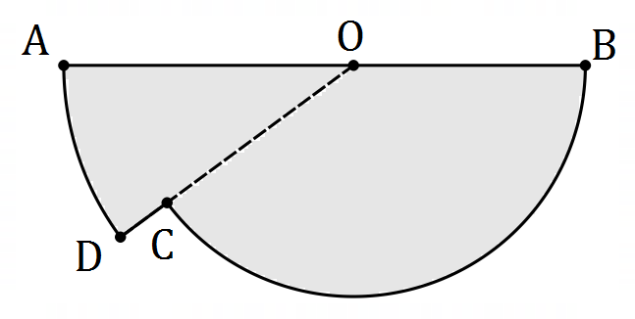

(a) Determine the length $OA$. (2 marks)

(b) Determine the area of the shape. (3 marks)

Question 10 (8 marks)

The height $h$ metres of a particle above level ground is defined as a function of time $t$ seconds as follows:

$$h\left(t\right)=68.75+15t-5t^{2}, 0≤t≤5.5 .$$

(a) Determine the height of the particle when

(i) $t=0$. (1 mark)

(ii) $t=4.5$. (1 mark)

(b) Determine the maximum height reached by the particle and the time it reached this height.

(2 marks)

(c) Determine the time(s) that the particle was at a height of $75$ m. (2 marks)

(d) State the range of the function $h(t)$ for the given domain. (2 marks)

Question 11 (6 marks)

Two events are such that $P\left(X\right)=0.2$, $P\left(Y\right)=0.5$ and $P\left(Y | X\right)=0.1$.

Determine the probability that

(a) both events occur. (2 marks)

(b) at least one event occurs. (2 marks)

(c) neither event occurs. (1 mark)

(d) $X$ occurs given that $Y$ has occurred. (1 mark)

Question 12 (8 marks)

The height above ground level, $h$ m, of a seat on a steadily rotating Ferris Wheel $t$ minutes after the wheel begins to move is given by $h=21.5-18.5\cos\left(\begin{matrix}πt \\ \overline{ 6 }\end{matrix}+\begin{matrix}π \\ \overline{3}\end{matrix}\right).$

(a) Determine the initial height of the seat. (1 mark)

(b) Graph the height of the seat against time on the axes below. (4 marks)

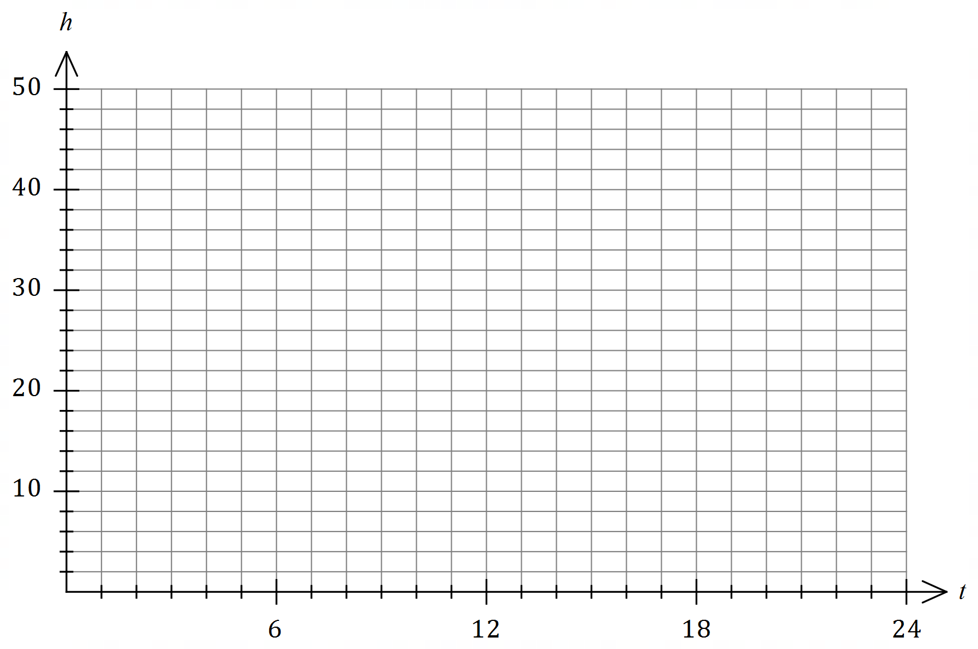

(c) Determine

(i) the maximum height above ground reached by the seat. (1 mark)

(ii) the time taken, to the nearest second, for the seat to first reach a height of $4$ m above ground level. (2 marks)

Question 13 (6 marks)

The graph $y=f(x)$, where $f(x)=x^{2}+bx+c$ has a turning point at $(2, -7)$.

(a) State the equation of the line of symmetry for the graph of $y=f(x)$. (1 mark)

(b) Determine the value of the constant $b$ and the value of the constant $c$. (3 marks)

(c) The graph of $y=f(x)$ is translated $3$ units to the left and $2$ units upwards. Determine the equation of the resulting curve. (2 marks)

Question 14 (6 marks)

When a random sample of $173$ people from a university were classified according to whether they had a driver's licence (event $D$) and whether they wore spectacles (event $S$), it was observed that

$n\left(D\right)=140$, $n\left(S\right)=53$ and $n\left(S∩\overline{D}\right)=10$.

(a) Determine

(i) $n(\overline{S})$. (1 mark)

(ii) $n(D∩S)$. (1 mark)

(b) Determine the probability that a randomly chosen person from the sample

(i) does not have a driver's licence. (2 marks)

(ii) wears spectacles given that they have a driver's licence. (2 marks)

Question 15 (8 marks)

Consider part of the unit circle shown below, where $θ=51°$.

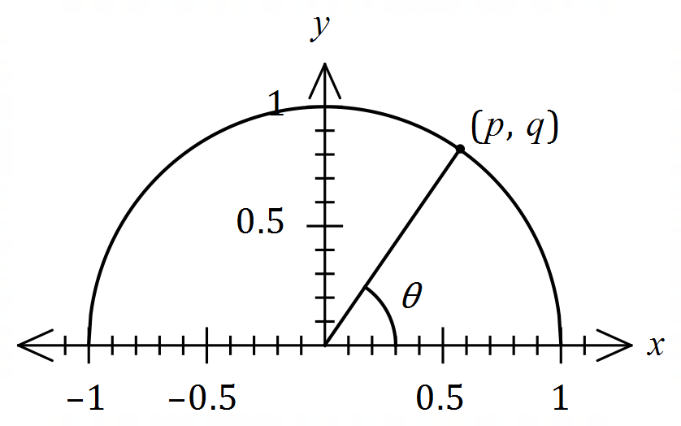

Determine, in terms of $p$ and / or $q$, an expression for each of the following:

(a) $\sin{51°}$. (1 mark)

(b) $\cos{129°}$. (2 marks)

(c) $\sin{141°}$. (2 marks)

(d) $\cos{258°}$. (3 marks)

Question 16 (8 marks)

A polynomial of degree $3$ passes through the points with coordinates $\left(0, 4\right), \left(-2, 0\right), (2, 0)$ and $\left(0.5, 0\right)$.

(a) Determine the equation of the polynomial in expanded form. (4 marks)

(b) Draw the graph of the polynomial on the axes below, indicating the coordinates of all turning points. (4 marks)

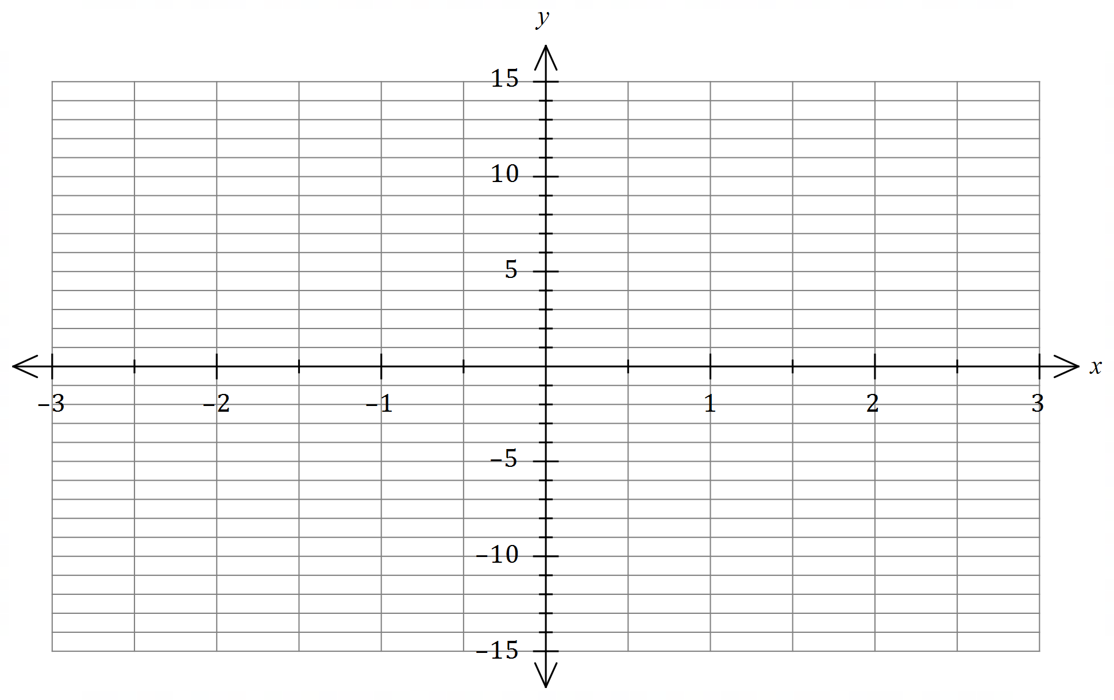

Question 17 (7 marks)

Let $f\left(x\right)=1+\sqrt{6-2x}$ and $g\left(x\right)=x+2$.

(a) Evaluate $f\left(-5\right)-g(-5)$. (2 marks)

(b) State the domain of $f(x)$. (2 marks)

(c) State the range of $g(x)$. (1 mark)

(d) Determine the coordinates of the point(s) of intersection of $y=f(x)$ and $y=g(x)$.

(2 marks)

Question 18 (8 marks)

The graph of $y=f(x)$ is drawn below, where $f\left(x\right)=\sqrt{x+a}+b$.

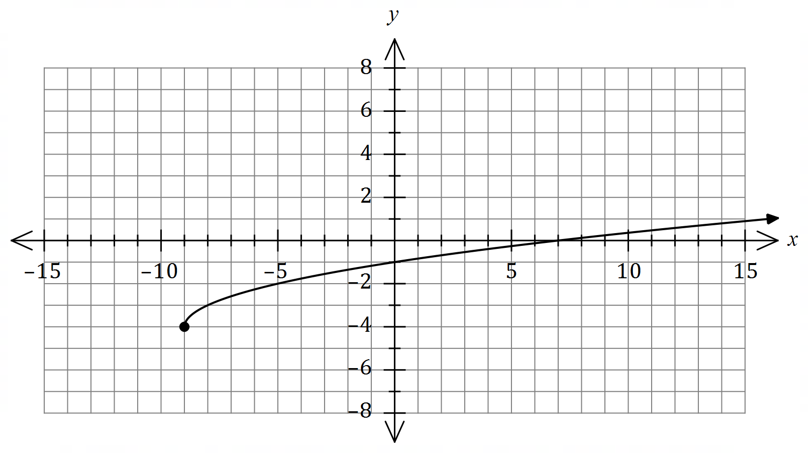

(a) Determine the value of the constant $a$ and the value of the constant $b$. (2 marks)

(b) Draw the graph of $y=-2f\left(x\right)$ on the axes below. (3 marks)

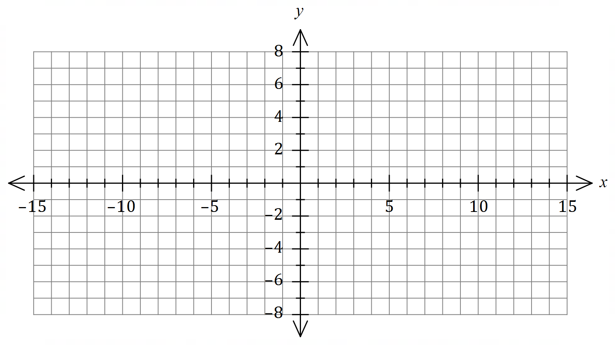

(c) Draw the graph of $y=f\left(2x\right)$ on the axes below. (3 marks)



Question 19 (9 marks)

The graph of $y=f(x)$ is shown, where $f\left(x\right)=\begin{matrix}a \\ \overline{x+b}\end{matrix}+c$ and $a, b$ and $c$ are constants.

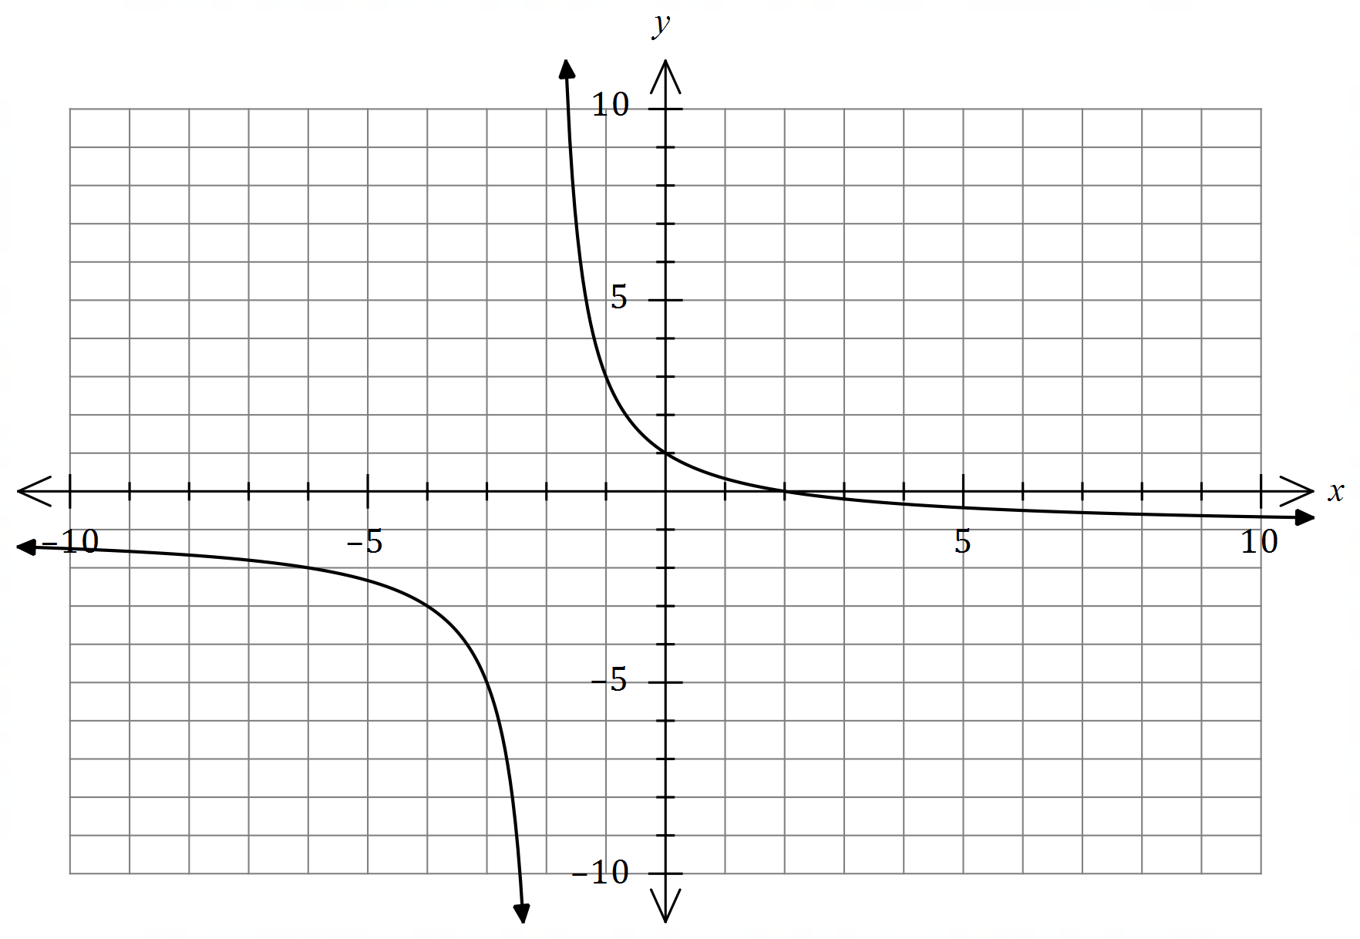

(a) Determine the value of $a$, the value of $b$ and the value of $c$. (3 marks)

(b) State the domain and range of $f(x)$. (2 marks)

(c) On the axes below, draw the graph of $y=2-f(x)$ and label all asymptotes with their equations. (4 marks)

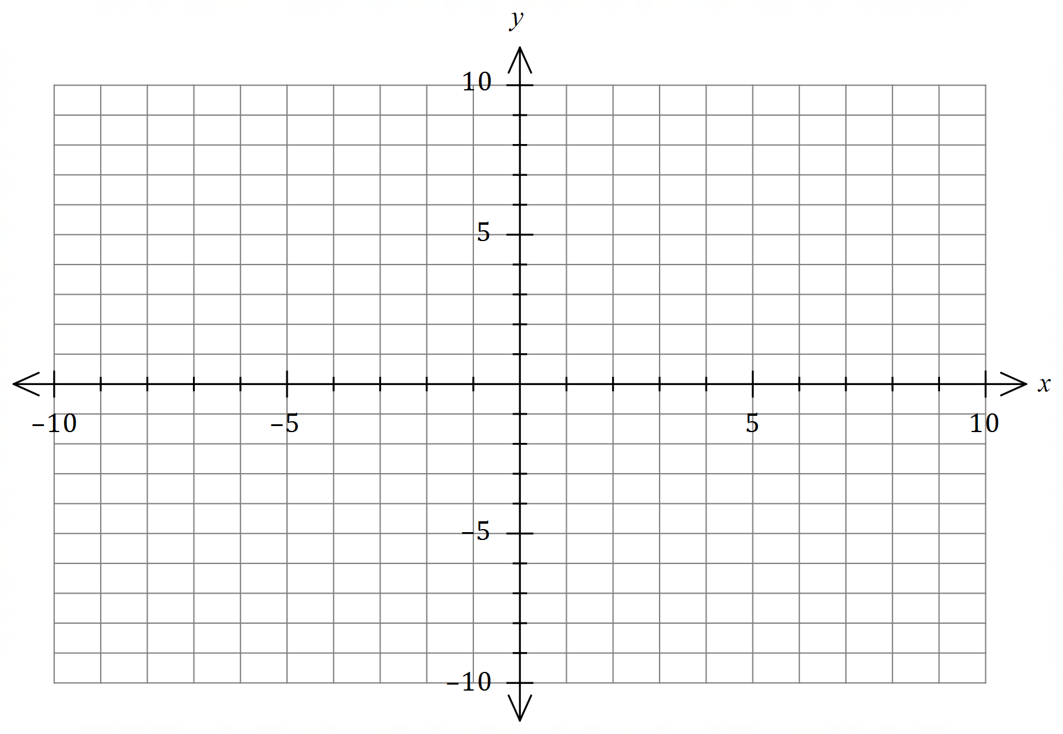

Question 20 (11 marks)

(a) Determine the area of triangle $PQR$ when $∠PQR=26°$, $∠PRQ=122°$ and $PQ=57$ cm.

(4 marks)

(b) The area of triangle is cm2, and as shown in the diagram. Determine the length of $AB$. (4 marks)

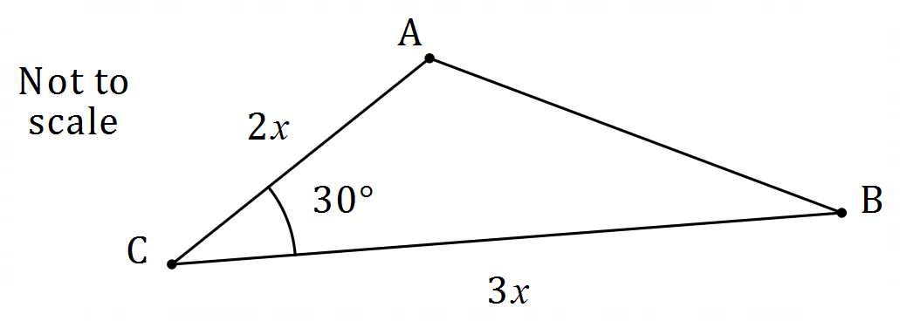

(c) In triangle $ABC$, $AC=65$ cm, $AB=44$ cm and $∠ACB=37°.$ Determine the smallest possible area of the triangle. (3 marks)

Question 21 (8 marks)

The graph of $y=a+b\sin{(x-c)}$ is drawn below, where $a, b$ and $c$ are positive constants.

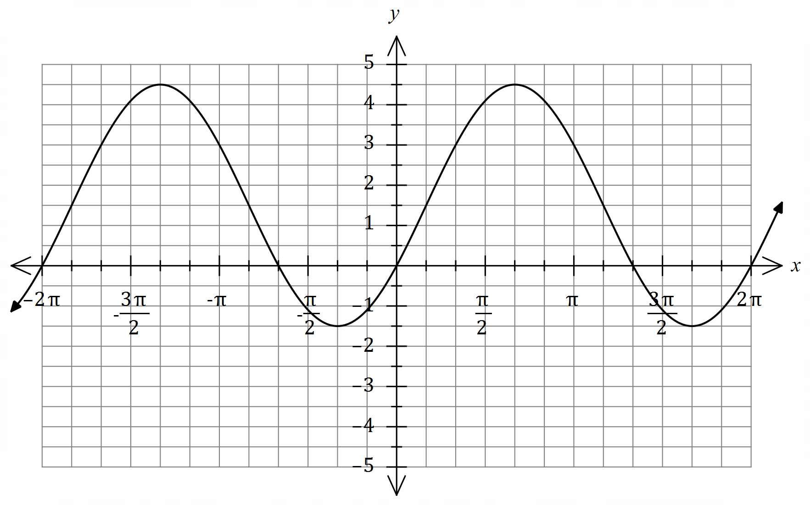

(a) Determine the value of $a$, the value of $b$ and the value of $c$, where $c<π$. (3 marks)

(b) On the same axes, draw the graph of $y=a+\begin{matrix}b \\ \overline{2}\end{matrix}\sin\left(x+c\right)$. (3 marks)

(c) Solve $b\sin{(x-c)}=\begin{matrix}b \\ \overline{2}\end{matrix}\sin\left(x+c\right)$ for $-π≤x≤π$. (2 marks)

**Additional working space.**

**Question Number:_________**

**Additional working space.**

**Question Number: _________**